**Enter an Agreement**

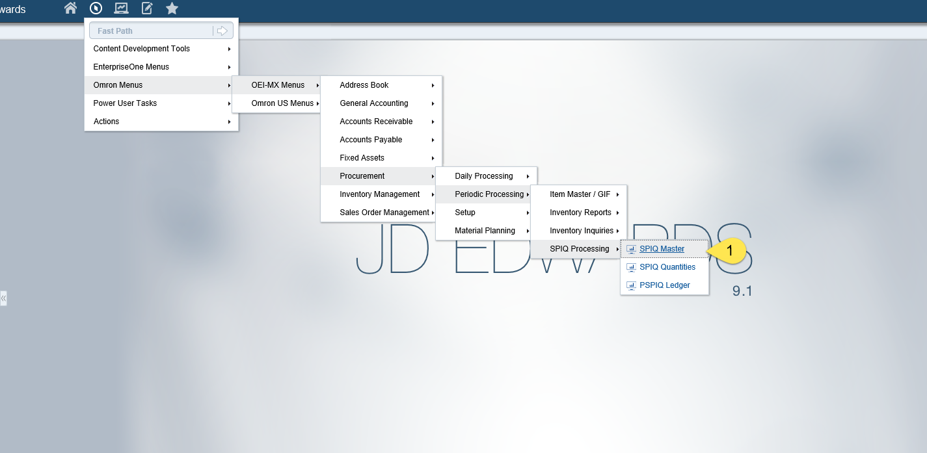

1. Select SPIQ Master from the menu

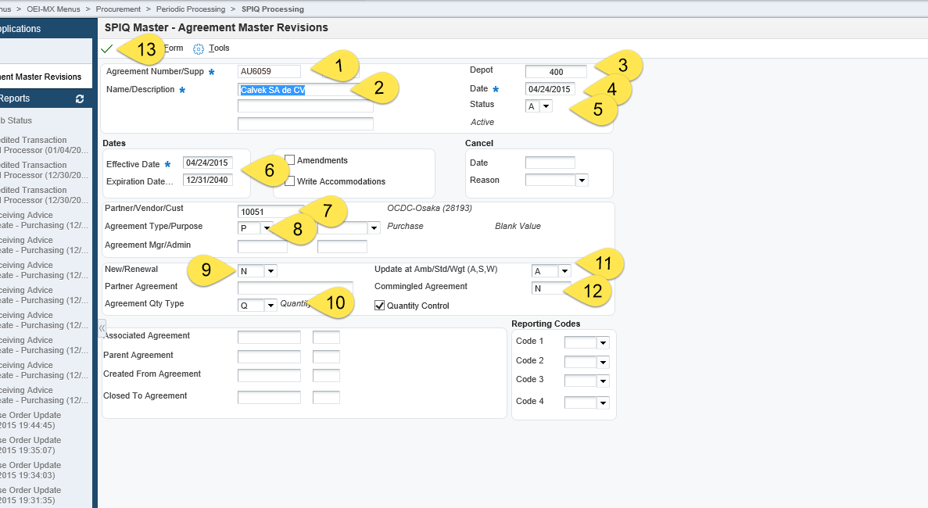

1. Agreement Number
2. Description
3. Depot = Branch Plant that the item/order resides
4. Date = Date the Agreement was entered (required)
5. Status = A = Approved (required)
6. Effective Dates – Dates the Agreement is effective. This will be related to the line detail which must fall within these dates or there will be an error.
7. Parent = AB# for Vendor Supplier
8. Agreement Type/Purpose = P
9. 9-12 should default as seen in the screenshot
10. #13 Click OK

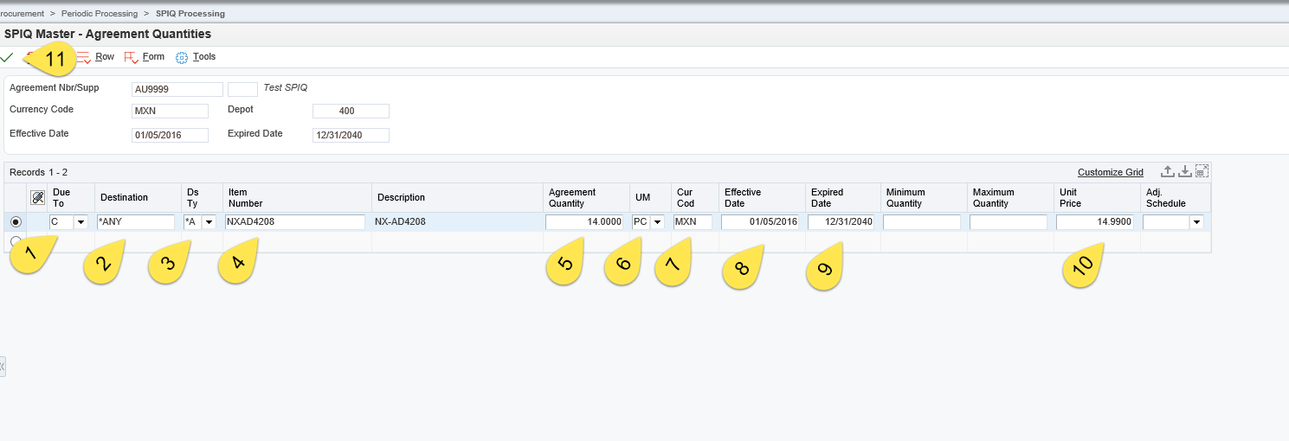

1. Due To = C
2. Destination = *ANY
3. Ds Ty = *A
4. Item Number
5. Agreement Quantity
6. UM (unit of measure) = PC
7. Cur Cod = MXN or USD or relevant Currency
8. Effective Date – must be within the range above
9. Effective Date – must be within the range above
10. Unit Price = Price agreed upon
11. Click OK